
Center of Excellence


WIRELESS AND INFORMATION TECHNOLOGY

*AT STONY BROOK UNIVERSITY

NEXT GENERATION RESEARCH AND INNOVATION

CEWIT An Overview

Director’s Message
Information Technology will continue to create new and highly profitable businesses that we have not even imagined. Computational chemistry and biology, grid computing, tying far flung supply chains, and e-commerce are at the beginning of their creation. Data is now the raw material for the information economy, much as coal and iron ore were in the Industrial Revolution. Within the so-called “Internet of Things,” sensors are being embedded in devices ranging from smartphones,
automobiles, and utility meters to assembly lines, warehouses, and hospitals to capture data in real time. Hundreds of millions of users around the globe now contribute new data, generating new knowledge and collaboration on new innovations using the Internet.

The Center of Excellence in Wireless and Information Technology (CEWIT) at Stony Brook University is a leading U.S. research institution focusing on cutting-edge research in wireless and IT. Our focus is to conduct basic research and the
commercialization of the resulting technologies. The Center’s facility has research laboratories, a state-of-the-art data center with multiple high-performance clusters, an optical network infrastructure, a lecture and meeting center, and videoconference facilities, as well as all customary laboratory infrastructure.

CEWIT aims to create an ecosystem and culture that will continue to drive innovation through large and small advances derived from joint research programs, cooperative development of platform technologies, reciprocal out-licensing of companies’ intellectual property, and through the promotion of leadership skills to foster collaborative relationships. We have research
and development strengths in a wide range of areas that are best aligned with a number of target industry sectors. We seek collaborations and are keen to build strategic alliances with business enterprises, academic and scientific communities, and government entities.


Satya Sharma, PhD, MBA Executive Director, CEWIT

Leadership

Richard Reeder, PhD
Vice President for Research Stony Brook University

Peter Donnelly
Associate Vice President for Technology Partnerships, Economic Development

Yacov Shamash, PhD
Founder and Co-Chair, CEWIT Advisory Board

Rong Zhao, PhD, MBA
Center Director

Arie Kaufman, PhD
Chief Scientist

Sangjin Hong, PhD
Director, Globalization

David Hamilton
Director, Programs, Economic Development

Fan Ye, PhD
Director, Communications and Devices

CEWIT Home of Innovation

Our Mission
To create high quality jobs within New York State; to create leaders of tomorrow in information technology; to drive innovation through joint R&D programs with industry and academic partners; to develop and commercialize university research projects; to foster new enterprise development.

Our Facility
CEWIT is a 100,000 square feet building which was designed to enable an extraordinary scope of activity. CEWIT fosters specialized research and development in all major areas of information technology for 80+ faculty affiliates and over 300 graduate students promoting interdisciplinary work among various specialties.
The facility includes these noteworthy resources:
- 40 Research labs
- SMART Cluster (Strategic Machine-Learning Acceleration and Ray Tracing)
- Reality Deck, a fully immersive gigapixel display with 1.5 billion pixels
- Virtual Silo, a circular cylinder of 0.6 gigapixels in stereo
- Immersive cabin capable of creating a synthetic, fully immersive, 3D virtual environment
- Cybersecurity and information assurance laboratories
- Mobile computing testbed for ad hoc and other emergency networks
- Motion capture laboratory for face recognition and surveillance
- 3D scanning laboratory for high speed and high percision data capture and automated image analysis
- Bioinformatics laboratory for computational genetics, protein docking, and biostatistics networking
- Future home demonstration site for simulating smart sensor assisted living and aging
- MoCA lab, data centric edge communication and computing, smart aging and health systems
- Smart Grid Resiliency Laboratory for micro grid demonstration
- 15,000 square feet of technology incubator space and support services for technology startups

Advisory Board

Russell Artzt
Co-Chair, CEWIT Advisory Board Executive Chairman, RingLead, Inc.

Otto Berkes
Former CTO, CA Technologies

Kamal Bherwani
Executive Chairman, Magine TV

Richard Boivie, PhD
Senior Technical Staff Member, IBM

Steven Cento
Sector Engineering Fellow Northrop Grumman Corporation

Jennifer L. Costley, PhD
Director, Physical Sciences,Sustainability and Engineering, NY Academy of Sciences

Jim Harding
Special Advisor to the CEO, Henry Schein, Inc.

Masaaki Maeda
Strategic Advisor, Asurion, LLC

Christopher Pendegast
Chief Technology Officer, Henry Schein, Inc.

Alex Price
Senior Vice President, Demand Solutions

Bob Sanders
Senior Vice President, Zebra Technologies

Yacov Shamash, PhD
Founder and Co-Chair, CEWIT Advisory Board

Satya Sharma, PhD, MBA
Executive Director, CEWIT

Kevin Tracey, MD
President
Feinstein Institute for Medical Research

Adam Weisman
Retired Partner, Deloitte

CEWIT Research Divisions

Communications and Devices
Network Technologies

The Network Technologies Division focuses on research, development, and commercialization of next generation wireless networks, multimedia mobile devices, and advanced solutions
and services. Research activities in this division include network design, modeling, implementation and testing of various forms of wireless ad hoc, sensor, and mesh networks;
protocol design for wireless and mobile networks, vehicular networks; network planning and management; network security; location management and tracking; and physical layer aspects such as MIMO.

- Accessing Urban WiFi Networks from Moving Vehicles
- Cellular and Mobile Networks Security
- Data Driven Mobility Modeling for Wireless Networks
- Network Planning and Real-time Automated Management System
- Self Powered Wireless Sensor Technology for Monitoring Electric Power Transmission Systems
The Communications and Devices Division focuses on circuit design and testing, fabrication and prototyping, and wireless/mobile computing device design and testing. The research activities in this division include, but are not limited to, digital signal processing, new sensor and RFID Systems, optical packet interconnects, wireless/mobile/ vehicle/drone communications,
image processing, micro-machining, superconductor electronics, trusted hardware devices, and spectrum sharing.

- Data-Centric Wireless Communication for Vehicle, Drone, and Edge Communications
- Enabling Interoperable Public Safety Rad10 Communications
- A Flexible Network Infrastructure for Versatile Wireless Communications
- Mobile Data Gathering in Wireless Sensor and Internet-of-Things Systems

Systems and Infrastructure
The Systems and Infrastructure Division focuses on developing applications based on the research conducted in the other divisions.
The division is not only advancing research in related fields, but is also creating solutions and systems for commercialization. The activities in this division include, but are not limited to, mobile technologies for social impact, image processing, robotics, social networks, data visualization
and visual analytics, applications of sensor networks and signal processing, smart transit systems, learning,
secure storage, service-oriented architectures, fault diagnosis, web information systems, reconfigurable hardware, and regulatory compliance.

- Advanced Documentation of Clinical Encounters and Context Award Presentation for Next Generation Electronic Medical Records
- Multiple Dimensional Data Visualization Made Accessible Using Illustrative Techniques
- Intelligent Mobile Technologies for Social lmpact
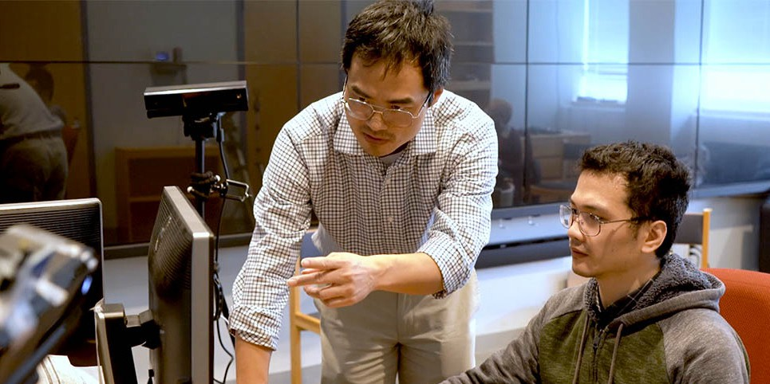
- A Multi Semantic, Goal Oriented Programming Paradigm for Dependable Operation of Massively Distributed Reconfigurable Systems
- Wireless Utility Monitoring and Control for Efficient Energy Utilization

Medical Devices and Technologies
Software Systems

The Software Systems Division focuses on developing and commercializing cutting-edge wireless/mobile computing and other software technologies including data management and analysis, data visualization, graphics and imaging, software and computer security, storage and file systems, distributed systems, user interface, Internet computing, software engineering, verification and optimization, parallel computing, statistical analysis and modeling, computational biology, and natural language processing. The research activities in this division include, but are not limited to,
cybersecurity, testing and verification, computer games, simulation and rendering, 3D visualization, cryptography, data modeling, algorithms, operating systems, geometric modeling, news and blog analysis, quality assurance, secure data management, virtual reality, file systems, augmented reality, bioinformatics, data mining and computational biology.

- The Cloud Computing Benchmarking Project
- Evidence Based Utilization Management of NYS Medicaid Program
- Instructional Technologies: The Future of Teaching and
Learning
- Novel Interaction Techniques for Virtual Environments
- Volumetric Shape DNA

Recognizing the dominant role of CEWIT in modern medicine, the Medical Technologies and Healthcare Division (CEWITMD) was established in 2008, and very soon became the largest division within CEWIT. The Goal of CEWITMD
is to conduct research and development leading to the building, prototyping and marketing of medical devices, products and technologies that support patients and clinical care providers. The Division research areas are diverse
and cover wireless medicine, the cardiovascular system, radiology, clinical pharmacology imaging modalities, virtual reality, telemedicine, wireless tracking, wireless ad hoc networks, home-care medicine, computational genetics and protein docking, implantable sensors and evidence-based medicine.

  - Wireless and Information Technology Emergency Health Monitoring Systems
  - Combined Near and Far Field UHF RFID Based Specimen Inventory and Tracking System
  - Implantable Sensors
  - Integrated Modeling and Learning of Multi-modality Data Across Subjects for Brain Disorder Survey
  - Self Powered Wireless Health Monitoring System
  - Computational Systems to Support Clinical Practice
  - Patient Monitoring, Cloud Computing and Health Care in Emergency Units

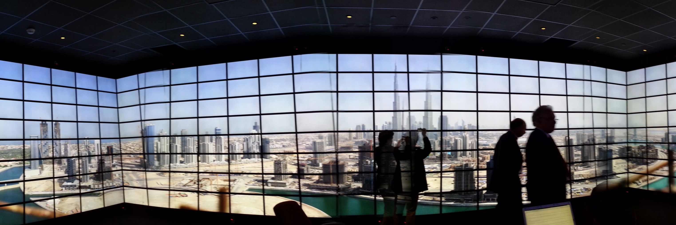

CEWIT Unparalleled Resources and Programs

Technology Resources

24
Tensor Peta FLOPS
- 1.5 Billion pixel Reality Deck
- State-of-the-art data center
- Private enterprise computing storage cloud
- Direct 500Mbps internet connection with redundancy
- SMART Cluster, Strategic Machine-Learning Acceleration and Ray Tracing Cluster
- The Virtual Silo, a cylindrical immersive stereo display

Accomplishments

27
Million Dollars In Industry Commitments
In The Last 3 Years
- 80 US patents
- 1,000+ jobs created or saved
- 1,000+ research publications
- 500+ projects completed
- 140 invention disclosures and 21 licenses
- 600+ student employees

New Enterprise Development

12
Startups Using Core Technologies Created at CEWIT
  - Akai Kaeru
  - The Arcon Group
  - Charmtech Labs LLC
  - General Sentiment, Inc.
  - Laufer Wind Group
  - Intelibs
    - Mechanismic, Inc.
    - Orchid Imaging
    - Private Machines, Inc.
    - Scandent LLC
    - Sunrise Technology, Inc.
    - Zortag

Programs

50+

International Expert Speakers Annually
    - CEWIT Conference: Annual conference on emerging technology for a smarter
world
    - HACK@CEWIT: Annual interdisciplinary student hackathon
    - Symposium Series: Academic research and industry innovations come together for critical and issue-relevant discussions with the experts
    - Incubator Showcase: Opportunity for Stony Brook University incubators to meet biotech, energy, and IT entrepreneurs

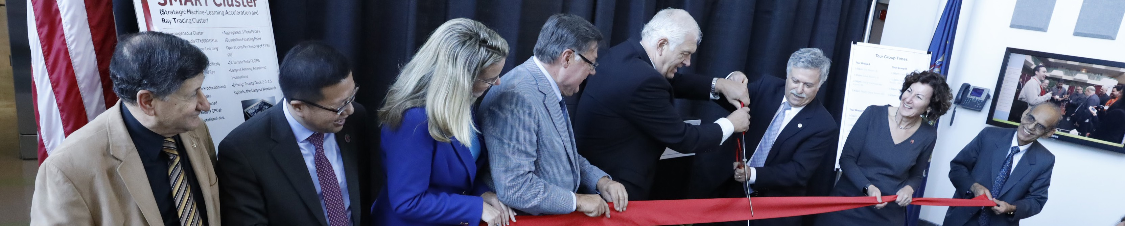

CEWIT And the Economic Development Partnership

As Long Island’s only major research university, Stony Brook University serves as the region’s hub for innovation and industry partnerships. SBU’s Economic Development enterprise, which has recently been incorporated into the Office of the Vice President for Research, collaborates with the region’s industry leadership and works with companies, start-ups and entrepreneurs through its Manufacturing Extension Partnership, the Manufacturing and Technology Resource Consortium,
two NYS Centers of Excellence in Advanced Energy and Wireless and Information Technology, two NYS Centers for Advanced Technology in Biotechnology and Energy Systems, 100,000 sf of incubator space and NYS Small Business Development Center, and advanced engineering assistance programs, leveraging the expertise of more than 900 externally funded researchers on campus and nearby Brookhaven National Laboratory, and a half-billion dollar plant of specialized facilities available to industry. Promoting the economic health of the region and the state is key to the University’s public service mission. In the last decade, Stony Brook performed more than 4,000 projects that helped almost a thousand Long Island companies create nearly 20,000 jobs and generate more than a billion dollars in business activity.

Economic Development

Peter Donnelly
Associate Vice President for Technology Partnerships

David Hamilton
Director, Programs
stonybrook.edu/ecodev

Advanced Energy Research and Technology Center (AERTC) David Hamilton
Chief Operating Officer
aertc.org

Business Incubator at Calverton

Hana Zuric
Assistant Director, Business Operations
stonybrook.edu/commcms/1-calverton

Center for Biotechnology (BioCAT)

Clinton Rubin, PhD
Director
centerforbiotechnology.org
Clean Energy Business Incubator Program (CEBIP) Heidi Anderson
Executive Director
cebip.org

Center for Integrated Electric Energy Systems (CIEES) Slowa Solovyov, PhD
Center Director
sbuciees.org

Intellectual Property
Partners (IPP)

Sean Boykevisch, PhD
Director
stonybrook.edu/ipp

Long Island High Technology Incubator (LIHTI)

Anil Dhundale, PhD
Executive Director
lihti.net

Manufacturing and Technology Research Consortium (MTRC) Cynthia Colon
Project Coorindator
stonybrook.edu/mtrc

Small Business Development Center (SBDC)

Bernie Ryba
Regional Director
stonybrook.edu/sbdc

Strategic Partnership for Industrial Resurgence (SPIR) Lisa Chichura, PhD
Managing Director
stonybrook.edu/spir

Thermomechanical & Imaging Nanoscale Characterization (CMIC/ThINC)

Glen Itzkowitz, MA, MBA
Director Associate Dean, Facilities & Operations
stonybrook.edu/thinc

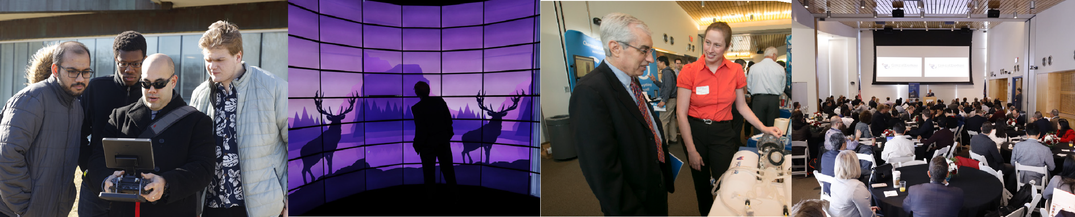



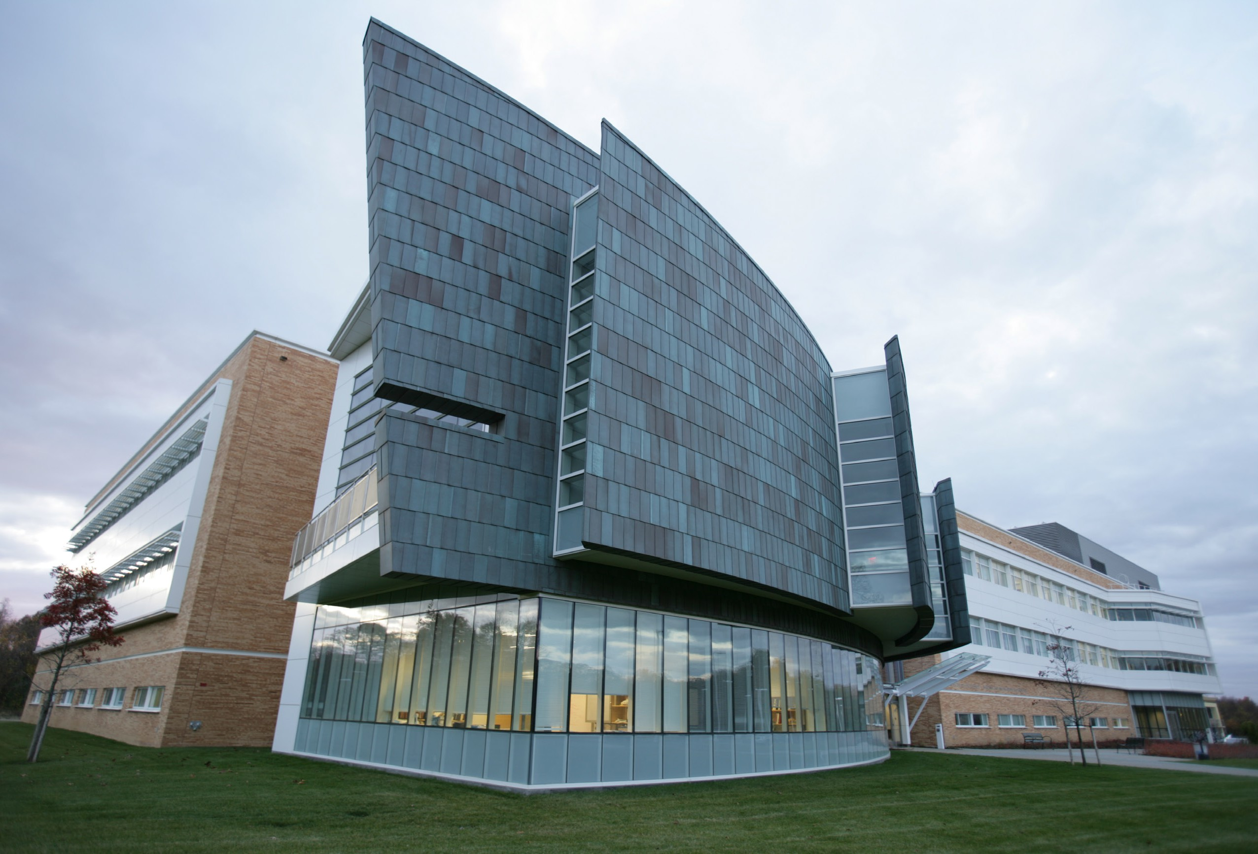
CENTER OF EXCELLENCE IN WIRELESS AND INFORMATION TECHNOLOGY (CEWIT)

Stony Brook University Research and Development Park 1500 Stony Brook Road
Stony Brook, NY 11794-6040 Phone: (631) 216-7000
Email: info@cewit.org


cewit.org
Stony Brook University is an affirmative action/ equal opportunity educator and employer. This publication can be made available in an alternative format upon request.
© 2021 Stony Brook University

